AHADITHS
AHADITHS no 1
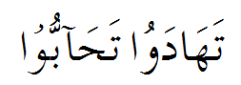
TRANSLATION NO 1
“Give gifts to each other, you will love each other”
EXPLANATION
Exchange of gifts will always increase love between each other, so we have to express our love by giving gifts to our friends, relatives, and family members and we have to give respect to our elders because for elders the biggest gift is respect of them.

AHADITHS no 2
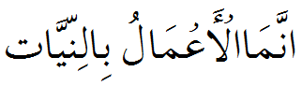
TRANSLATION NO 2
“Actions are judged by intentions”
EXPLANATION
The above hadith is considered one the “Pivots-of-Islam Hadith”. This is because it relates to ones outward actions and makes clear that the acceptance of these outward actions are intrinsically related to ones intentions.Both Imam Shafi`i and Imam Ahmad ibn Hanbal stated that this hadith conveyed a third of the knowledge of the religion. This is mainly because the religion is a combination of three things
[1] The tongue
[2] The various body parts such as hands, feet and so forth.
[3] The heart
“The intention of a believe is better then his action.”
the difference between `amal and fi`l is that an `amal is done after thinking and contemplatingHowever, a fi`l is general (aam) and refers to acts done knowingly or unknowingly.Thus, we see that when pointing to good actions, which remain consistent and continuance, the Prophet (Allah bless and grant him peace) used the word
“a`maal’and not “af`aal“. This is the same reason why the Qur’an uses the word `amal at various places to describe rightous deeds.
“By saying “Actions are by Intentions,” the Prophet (Allah bless him and grant him peace) meant acts of obedience at the exclusion of permitted actions that are neither recommended nor disliked.”

AHADITHS no 3
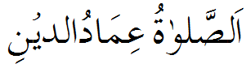
TRANSLATION NO 3
“Worship is the pillar of Islam”
EXPLANATION
The second pillar of Islam is salaat whereon stands the structure of Islam. Said Umar (R.A) “HE WHO HAS GUARDED HIS SALAAT AND IS PUNCTUAL THEREIN WILL HAVE GUARDED THE REST OF HIS DEEN, WHILE HE WHO HAS DESTROYED IT. WILL HAVE DESTROYED THE REST OF HIS DEEN EVEN MORE GREATLY” For this reason, salaat is regarded as a very great pillar. And this neglector threatened with kufr.
AHADITHS no 4
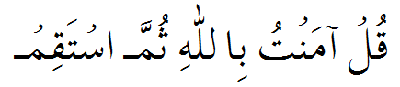
TRANSLATION NO 4
“Say I believe in God and act uprightly”
EXPLANATION
This all embracing advice, covers all aspects of Deen, including belief and actions. The utterance of the fundamental motto of Islam, “Amanto billlahie” I have brought believe in Allah affirming thereby that one has become a mumin believer, and then to remain steadfast thereon. Believe on Allah means the acceptance of all the fundamentals of deen, and on becoming a Mumin, it becomes his duty to fulfill the demands of deen by adopting the qualities of believe. This means carrying out those deeds ordered or encouraged by Allah and avoiding those prohibited by him. A slave become steadfast, when in every condition and so every occasion, he remains conscious of Allah’s orders and avoiding Allah disobedience.
AHADITHS no 5
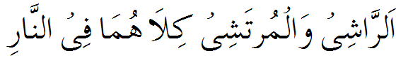
TRANSLATION NO 5
“The Giver and taker of Bribe both shall go to Hell”
EXPLANATION
The punishment for one who takes bribery, one who gives it and one who communicates between them is a curse and expulsion from the mercy of Allah by the tongue of the Messenger of Allah (Sallallahu Alaihi wa Sallam).
Prophet (Sallallahu Alaihi wa Sallam) cursed the bribe giver, its taker and the one who communicates between them both.
Bribery is one of the major sins. It is condemned and forbidden in the Book of Allah. In short, the punishment of the bribe-taker, the bribe-giver and the intermediary between them is great, if they do not repent to Allah from it. This is because bribery causes much corruption in the society.

AHADITHS no 6
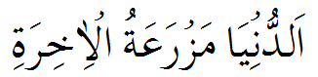
TRANSLATION NO 6
“This world is a cultivating ground for the hereafter”
EXPLANATION
This world is a field for action, wherein man utilize the resources of body and wealth, carrying out actions, people executing these action fall in to two categories. Firstly those who have made the object of their endeavours Allah’s pleasure and this is the main consideration whatever they ma do. Their actions will be beneficial for them saving hem from jahanum and causing their admission in to Jannat. Then there are those whose lifelong endeavours are directed to ward their perishable world, for the attainment of which no attention whatsoever is paid to the permissible and impermissible (halaal and haraam). Allah restrictions are flouted and they totally surrender themselves to their lowly dictates, soiling themselves in countless sins. Their actions will be excessively harmfull for them, leading them to jahannum.
AHADITHS no 7
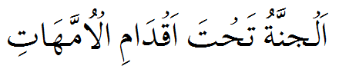
TRANSLATION NO 7
“ Paradise lies at the feet of the Mother”

EXPLANATION
Islam ordered us to respect and treat our parents and never to shout at them for any reason,ordered never to disobey them except when they order us to do something that is forbidden by God and still we must treat them kindly and respect our relationship with them.God also put our obedience tour parents as a second priority after his almighty obedience to express how important it is,and also told us that our good deeds will not be accepted unless our parents are all satisfied with us.Islam gave the first priority of obedience to the mother application to the saying(Hadith)of prophet Mohammed(PBUH)that says:
Someone went to Mohammed(PBUH)and asked him "Who has the first priorty to be well treated?"
Prophet Mohammed answered him "your mother",
He asked "then who?"
He(PBUH)answered"your mother"
Asked agin"then who?"
Answered (PBUH)"your mother"
Asked "then who?"
Mohammed answered(PBUH)"your father".
This is to show how important and precious mother is in Islam and how respectable
is her status. Islam gave the mother this status because:
1-Only God knows how do mother feel tired and sick during the pregnancy period.
2-The pain the mother bears during the delivery.
3-The breast feeding.
4-Who bears us when we are sick and stay up late for us? Mothers.
5-Mothers have more patience on their children more than anybody else.

AHADITHS no 8
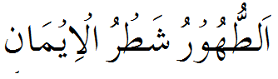
TRANSLATION NO 8
“Purity is the half the faith”
EXPLANATION
Islam greatly approves cleanliness.
When man rues his mistakes and returns to the path of truth, this is called an act of repentance. As such, it purifies man’s inner self. Just as by using water we can cleanse the dirt from the body so by repentance we can purify the soul—the inner-self. That is why Islam lays great stress on both these things.
Man is a creature who has been specially granted the quality of sensitivity. That is why man naturally likes cleanliness, and since Islam is a religion of nature, it lays great stress on cleanliness. Man’s body, his clothing and his home, should all be pictures of cleanliness.
The cleanliness of body and soul is one of the basic demands of Islam
.

AHADITHS no 9
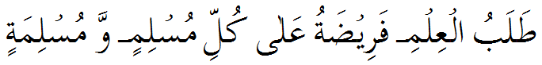
TRANSLATION NO 9
“To acquire knowledge is the duty of every Muslim Male and female”
EXPLANATION
What is required of an individual is only sufficient knowledge that can enable him or her to carry out their religious obligations. As a minimum every Muslim must learn the articles of faith and what they really mean. Heor she must also learn the laws and teachings of Shariah as they relate totheir life. The basic rule is that accompanying every religious duty is another duty to learn about the requirements of that duty. Thus it is our duty to learn Shariah teachings about Salaat, Fasting, Hajj, and Zakat. For a businessman, it is a religious duty to learn Islam's teachings about economics and halal and haram transactions. For a person getting ready to get married, it is a religious duty to learn Islamic teachings about marriage and spousal rights and responsibilities. And so on.
One must learn about the nature and forms of arrogance so it could be avoided. Similarly rage, jealousy, and malice. One must learn about desirable spiritual qualities like humbleness, patience, and gratitude. There is a surprising depth of knowledge about such subjects in Islamic literature. And although they may not seem to be important subjects for serious study, one can recount innumerable cases where Islamic communities have been damaged beyond repair by 'highly educated' people, who were uneducated in these subjects.

AHADITS NO 10
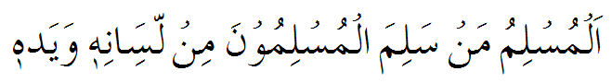
TRANSLATION NO 10
“A Muslim is he from the mischief of whose tongue and hands other Muslim are safe”

EXPLANATION
The mischief of the hands and tongue is mentioned because backbiting , lying e.t.c are all different from of the mischief of the tongue. Because when we use cruel language its painful for another person. So the lethal plague of backbiting destroys one's good deeds, destroys brotherhood and destroys one's reward. So the true Muslim does not backbite, nor does he allow backbiting to take place in his presence. So let those people fear Allah, those whose bodies do not develop and those whose spirit is not fed except upon spreading rumors and inventing lies against the servants of Allah

AHADITHS NO 11
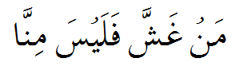
TRANSLATION NO 11
“One who cheats is not amongst us”

EXPLANATION
Islam order that a Muslim must be fair in his dealing and should not cheat to other person he never cheat in measurement commercial dealing. If he cheated to other person he will not amongst to us.

one who cheats is not among us, which means he is not among the perfect Muslims. It does not mean he is a blasphemer. It means he is not among the perfect Muslims (us the pious Muslims). He is an enormous sinner. He is a sinner.
One time the Prophet passed by a person who was selling wheat. This person had a pile of wheat in front of him which he was selling. The Prophet inserted his hand in that pile and he felt wetness (dampness??) inside the pile, which means some of the wheat was not in a good condition. The seller did not make it apparent; rather, he hid it. The Prophet said, “What is this?” (which means this should not be the way). He said, “Some rain fell on it.” The Prophet told him, “Then why didn’t you put it on the top so people can see it? The one who cheats is not following my methodology,” which means he is committing a sin.
If one buys something from another and they separate (the buyer leaves the session). Later, he regrets his purchase. He looks at the item that he bought and he wishes he didn’t buy it. If he comes back to the seller and tells the seller, “Take it back and give me my money back”, if the seller accepts for the sake of Allah, he gets reward in the Hereafter. This means it is better for the seller to accept. It is not an obligation that he accepts to return the item because after the contract was made, they separated from the session. So they were not still in the same session. But, if the seller accepts to return the item, he gets reward for that.
AHADITHS NO 12
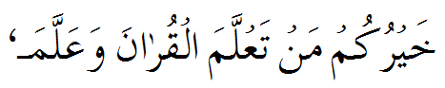
TRANSLATION NO 12
“The best amongst you is the one who learns the Quran and teaches it”

EXPLANATION
If we recite Quran again and again and we understand what Quarn says and we will teaches to other person we will best amongst person. Because quran is the book of allah
Which contain teaching and guides for all human beings. A believer will not be able to live their live according to the teaching of islam until he studied hole book of allah and understand what quran says.

AHADITHS NO 13
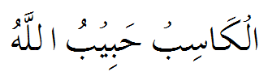
TRANSLATION NO 13

One who earns his livelihood by the sweat of his brow is friend of Allah.

EXPLANATION
Islam impugn Muslims that live their lives by legitimately, Hallal and prescribed Islamic ways and forbidden us to accept bribe or get money by unlawful means because ill gotten or ill spent wealth means we announce the battle against Allah. The relief one’s fear in scavenger and lawful earning is not in ill gotten wealth because the ill gotten wealth is always un blessed and unabundance by Allah. Whom live their life by the reinforcement of Allah always get vouchsafe abundance by Allah.

AHADITHS NO 14
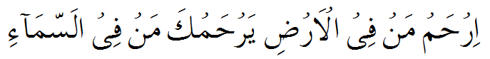
TRANSLATION NO 14
“Treat kindly the dwellers of the earth he who dwells in the heaven will treat you kindly”

EXPLANATION
In this Ahadiths hazrat Muhammad (S.A.W) impugn Muslim to treat every one younger or elder wealthy or unwealthy treat everyone equally and kindly. Be appeased with everyone no matter Muslim or non-Muslim or belong to another nation or country give every one regards and consideration. If we become gentle with everyone. Allah make the heaven slacken for us. And heaven treat us the same mild , gentle tender ways. If any one use harsh words or endure or put up with you always stay appease and soft spoken. Allah have the mercy for the people who love his creation and have a kind heart.
AHADITHS NO 15
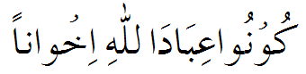
TRANSLATION NO 15
“O you servant of allah be brother”

EXPLANATION
In the ahadith hazrat Muhammad (S.A.W) united Muslim and make each other brother as a one soul. After the migration from makkah to madina the muslim of makkah are fully unequipped and helpless. Hazrat Muhammad (S.A.W) make everyone brother so they can share every thing with each behave gently , lovingly become helpful and merciful to each other.
AHADITHS NO 16
TRANSLATION NO 16

Feed and spread salam whom you know or you do not know.

EXPLANATION
When Islam came, Allaah prescribed that the manner of greeting among Muslims should be “As-salaamu alaykum,” and that this greeting should only be used among Muslims and not for other nations. The meaning of salaam (literally, peace) is harmlessness, safety and protection from evil and from faults. Allaah, the Sovereign, the Most Holy, the Peace, prescribed that the greeting among the people of Islam should be ‘al-salaamu ‘alaykum’, which is better than all the greetings of other nations which include impossible ideas or lies, such as saying, ‘May you live for a thousand years,’ or things that are not accurate, such as ‘An’im sabaahan (Good morning),’ or actions that are not right, such as prostrating in greeting. And you should fee the poor and needy person PROHET (S.A.W) SAID “THE BEST CHARITY TO SATISFY A HUNGRY BELLY” and spread salam where you know that person or not know that person.

AHADITHS NO 17
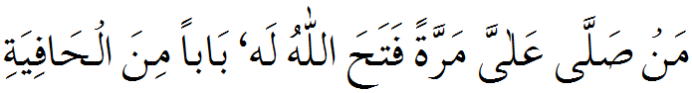
TRANSLATION NO 17
“Whose over invokes blessing on me once Allah will open the gate of safety”

EXPLANATION
Durood mean invocation and reciting durood upon hazrat Muhammad (S.A.W) means reciting invocation. It is a benedictory words upon hazrat Muhammad (S.A.W) and the person who reciting the durood and invocation upon hazrat muhammd (S.A.W) will be the nearest on the day of judgment to the prophet Muhammad (S.A.W)an Allah will give the divine favour, mercy and compassion upon the person.

AHADITHS NO 18
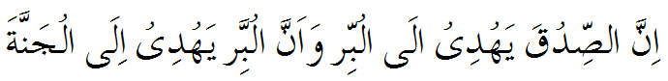
TRANSLATION NO 18
“Indeed trust leads to virtues and virtues leads to paradise.”

EXPLANATION
In islam the first step is to believe in Allah, his oneness and trust in his existence. Trusting in Allah always makes you virtuous and pious. The person having a good conduct and character and virtue in his heart. Its straighten the path for the person leads straight to the Jannat.

AHADITHS NO 19
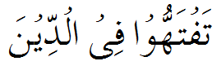
TRANSLATION NO 19
“Strive to develop and understanding religion”

EXPLANATION
Religion is a way to explain questions about the mysteries of life, survival in a cruel environment, moral and social rules, overcoming disease and life-after-death. Religious worship is a means affect the outcome of these concerns. People who have religions often have peace of mind and feel their spirit is nourished.

AHADITHS NO 20
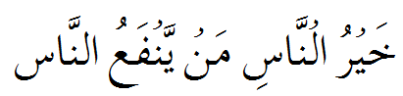
TRANSLATION NO 20
“The most among you is the one who is a source of benefits to the people”

EXPLANATION
Islam teaches us to help other peoples, to present your self as a benefit for other peoples ALLAH loves those who help peoples of ALLAH, so we have to try our best not to harm other peoples by our hand, by our tongues and by our whole self, we have to help poor peoples, visit sick peoples, respect to our elders and present our self as a benefit of whole mankind.
AHADITHS NO 21
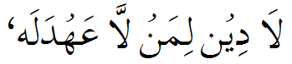
TRANSLATION NO 21
“He who does not keep a promise has no religion”

EXPLANATION
Islam teaches us to fulfill our promises. To break a promise in islam there is a big punishment , hadith is applicable to those who promise while intending not to fulfill it, or those who, without an excuse, decide later not to fulfill the promise. Those who promise but could not fulfill their promise due to a proper excuse are not hypocrites. But we should be careful not to present a false excuse.

AHADITHS NO 22
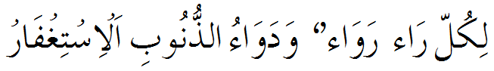
TRANSLATION NO 22
“There is a remedy for each disease and the remedy of sins is seeking forgiveness”

EXPLANATION
The hadith then illustrates excess sins with two examples. This is a means of further consolement for the Muslim. Even if his sins are as extensive as the area between the heavens and earth, Yet on seeking forgiveness, Allah will forgive if our sins blankets the ground, then his forgiveness too can blanket the ground, then his attributes of forgiveness is greater than that. The vastness of the heavens and earth is totally insignificant to his forgiving quality.

AHADITHS NO 23
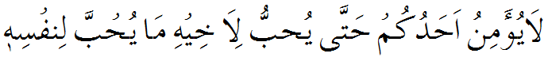
TRANSLATION NO 23
“None of you truly believes until he loves for his brother that which he loves for himself”

EXPLANATION
From this hadith, it become clear that we deal with everyone, liking for them what we would like for ourselves, and disliking for other what we would dislike for ourselves. For example if we are financially indebted to someone, let us think that if it was my debt (owed to me), I would desire to recover it as quick as possible. Therefore let me desire that some for him and repay it hastily similarly, if someone is financially indebted to us, think that if I was owing someone, would desire some respite (in repayment). Therefore, let me wish for him what I would have desire for myself, by granting him respite and he not harsh in my demand.

AHADITHS NO 24
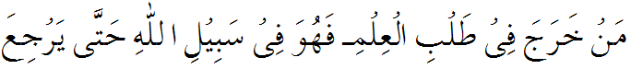
TRANSLATION NO 24
“He who leaves his home in search of knowledge walks in the path of Allah until he returns”

EXPLANATION
Islam regards the seeking of knowledge as an ethical essential and vital, and an endeavor highly pleasing to ALLAH. The Quran urges the seeking of knowledge so that through it both inner and outer reality must be transform.Numbers of saying of Holy Prophet peace be upon him which reflects the importance of education and knowledge including" The seeking of knowledge is obligatory upon every Muslim"; "Search for knowledge is compulsory for every Muslim, male and female”, "Search for knowledge though it be in China”; "Whoever searches after knowledge, it will be expiation for his past sins."

AHADITHS NO 25
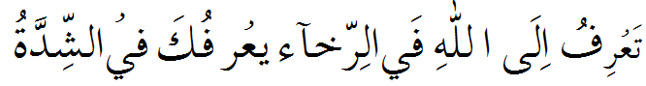
TRANSLATION NO 25
“Remember Allah in the days of abundance Allah will remember you in days of poverty”

EXPLANATION
Those who will remain steadfast (on the deen) in the days of abundance and remember Allah help and gentle with his creatures and thank him for his divine favor. Allah will give grace and mercy on him in the days of penury and impoverish

